HTTP Status Codes and Text

**200 OK** – For successful API message

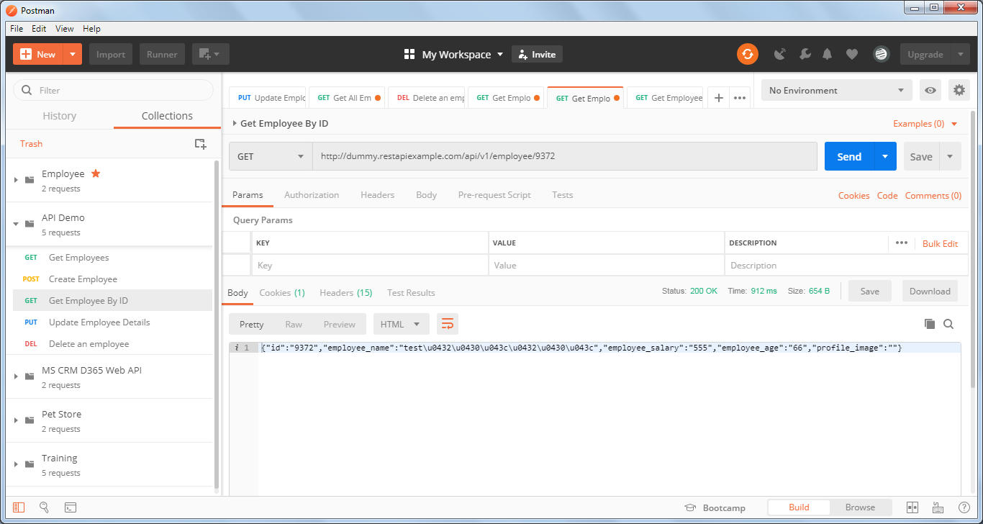

* **400 Bad Request** – Incorrect message body or some mandatory parameter missing in request body

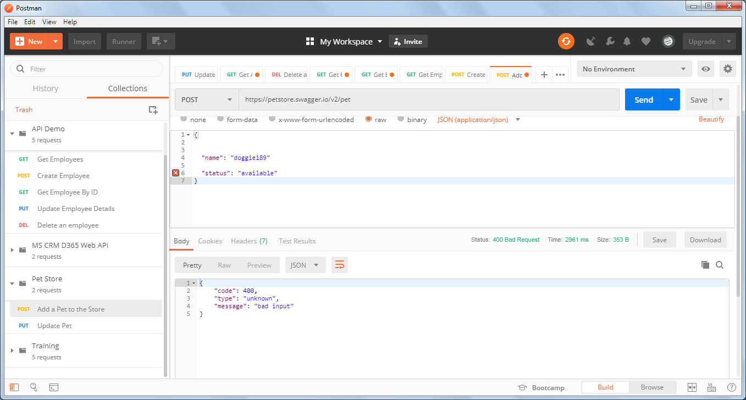

* **404 Not Found** – Incorrect URL or Resource not found

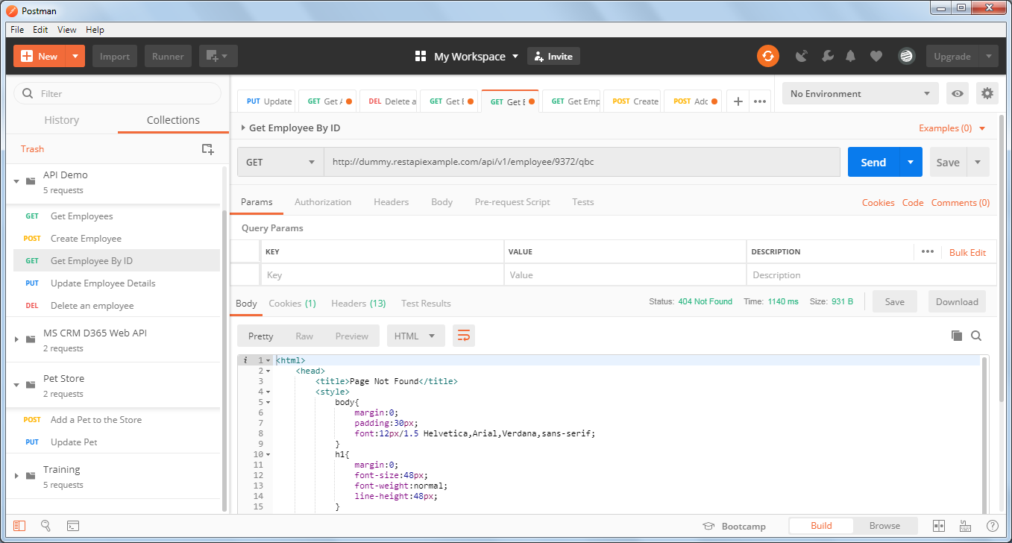

**500 Internal Server Error** – Unhandled Exception in the code

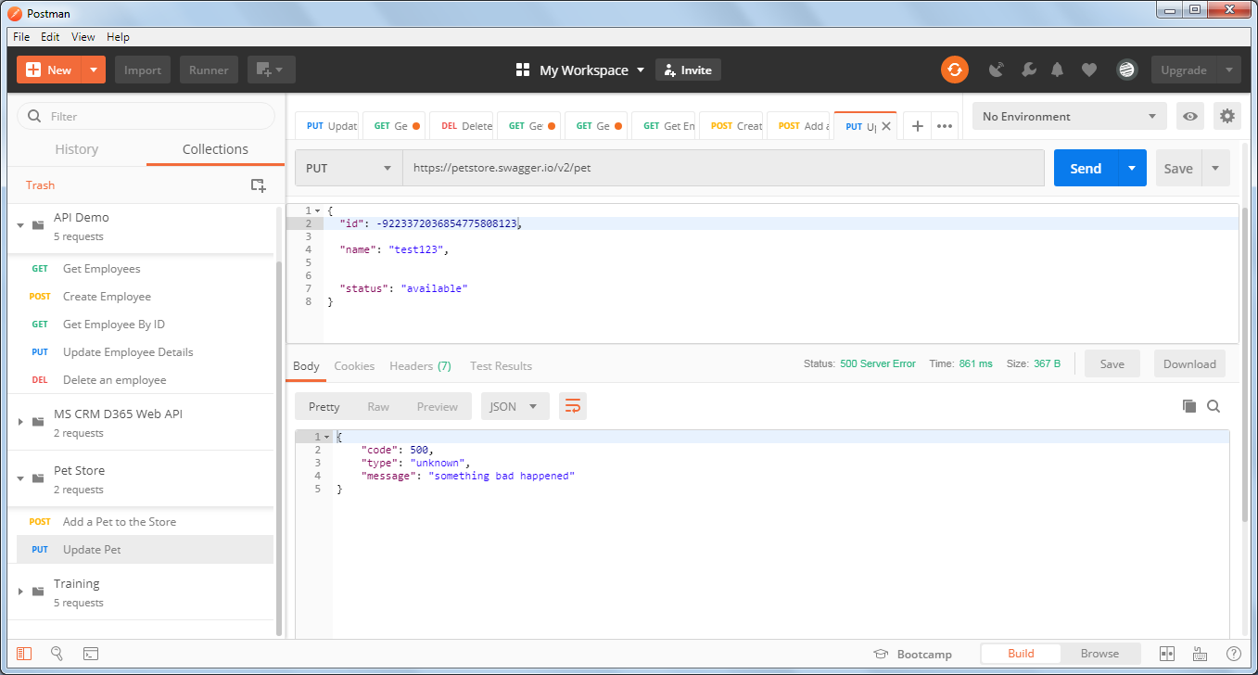

**401 Unauthorized** – Incorrect Authentications

